**ASSIGNMENT**

**MODULE 9**

**ELASTIC BEANSTALK**

**DONE BY**

**RANJITH KUMAR**

**Tasks To Be Performed:**

1. Create an Elastic Beanstalk environment with the runtime as PHP.

2. Upload a simple PHP file to the environment once created

STEP 1 : Open Elastic Beanstalk from aws services

STEP 2 : Click Create Environment

STEP 3 : Select webserver environment , platform as PHP

STEP 4 : Create an IAM service role and add administrator access for the Elastic beanstalk role

STEP 5 : Select Keypair(I have already a keypair)

STEP 6 : Create a IAM role for EC2 instance profile

STEP 7 : Select VPC , Availability zone , Subnets , Monitoring , Instance type and required information to create an environment

STEP 8 : Environment has created

STEP 9 : Select the environment > Upload and deploy

STEP 10 : Select the index.php zip file and upload it

STEP 11 : Now it displays the index.php file contets in the browser

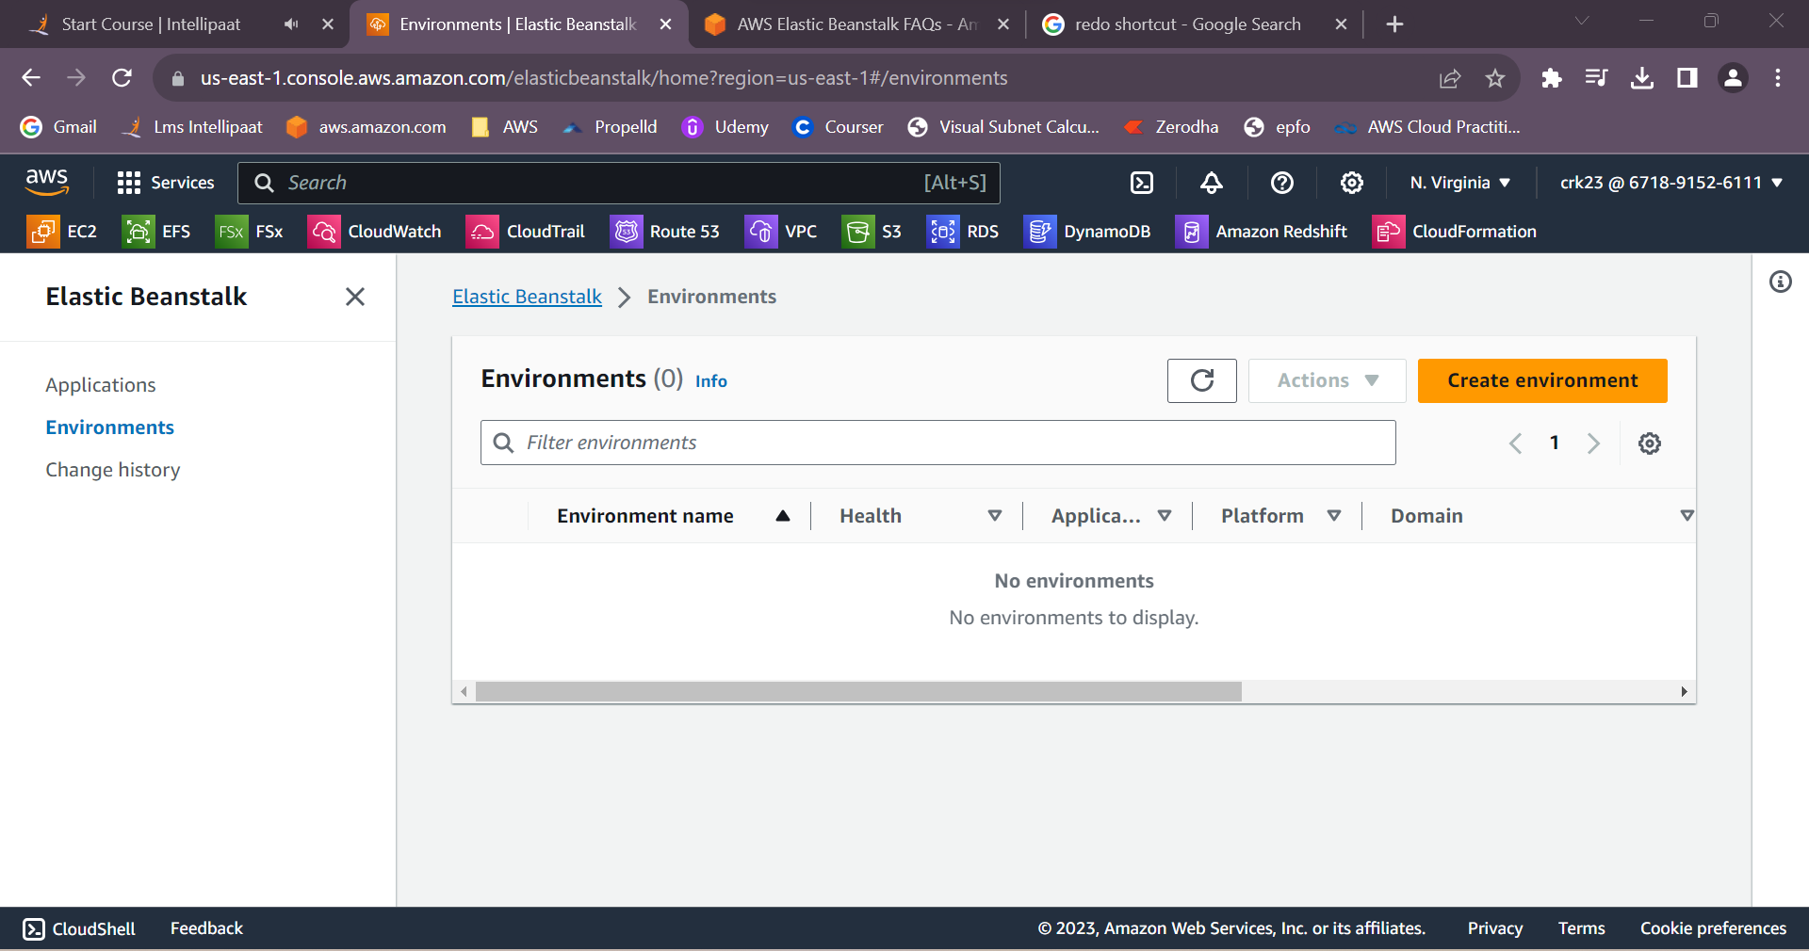

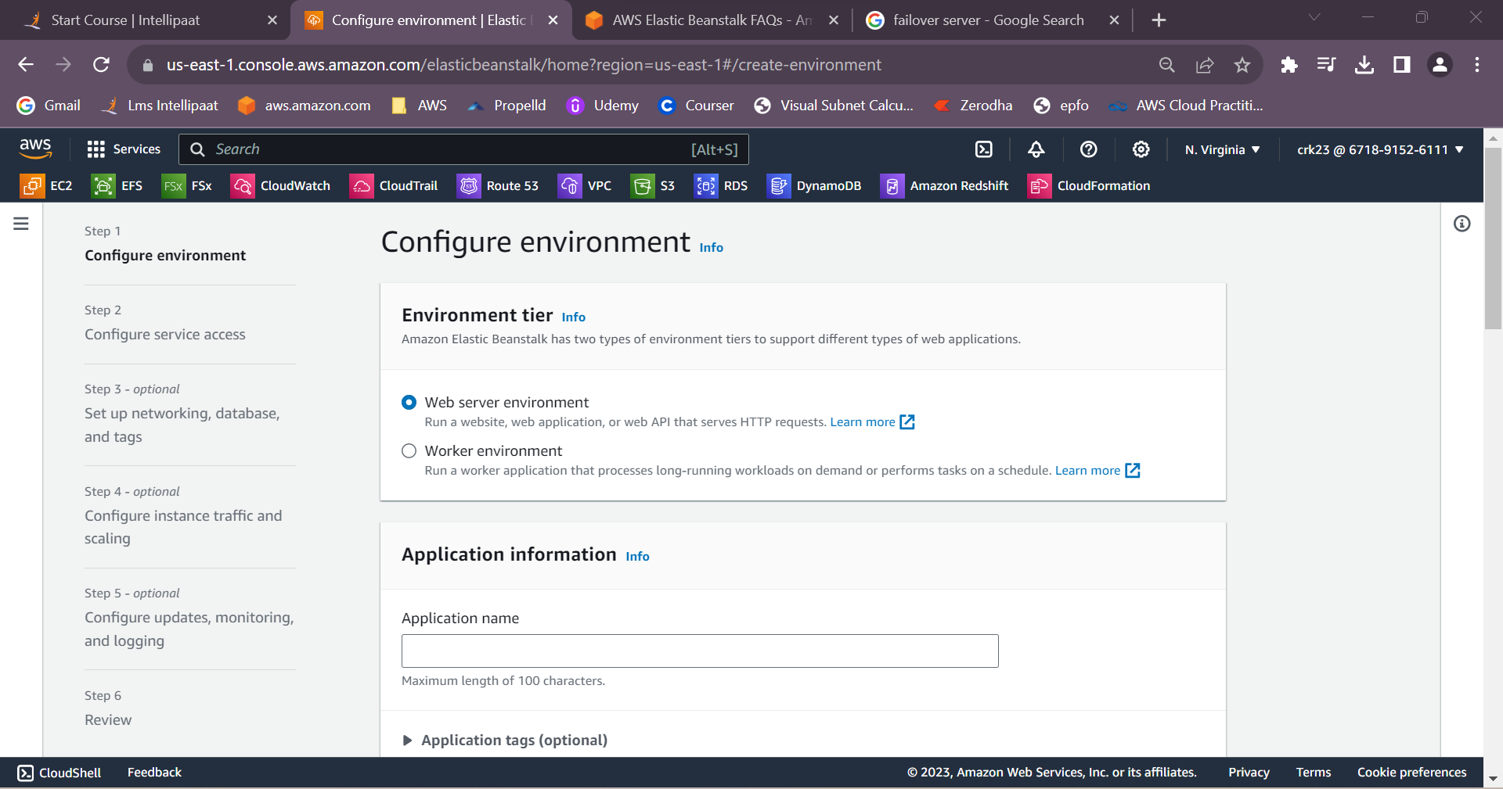

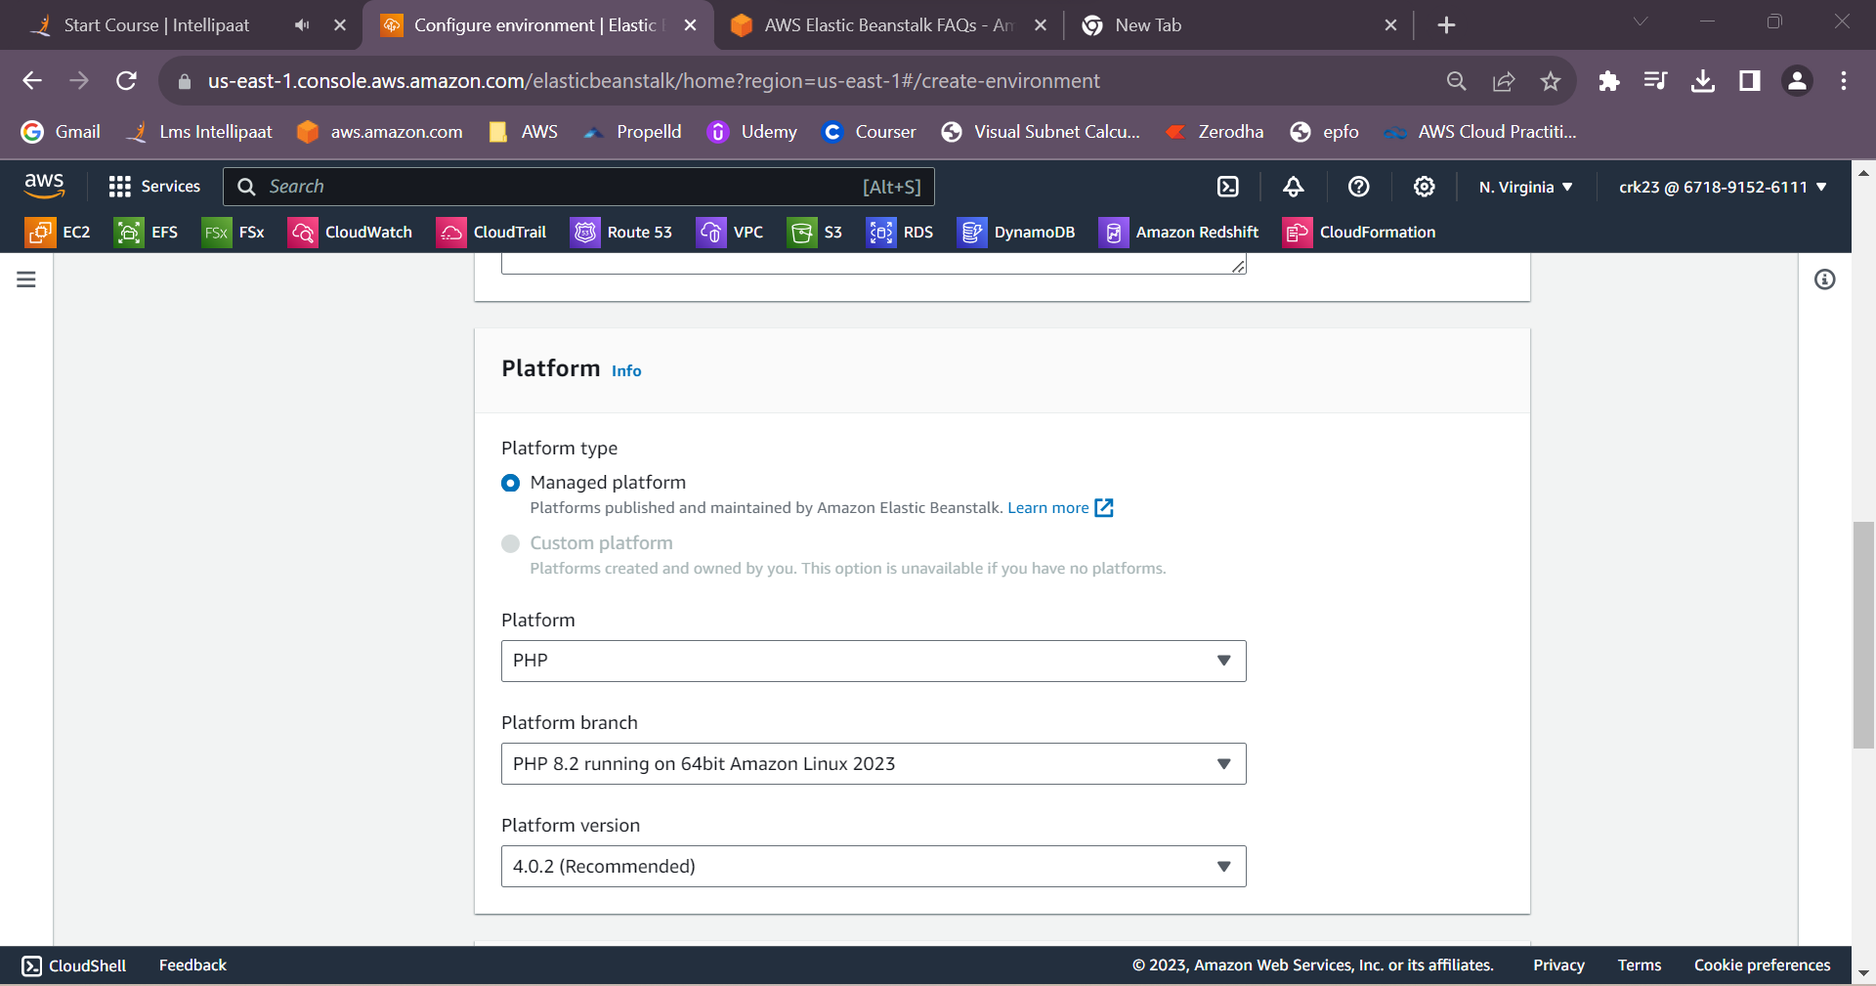

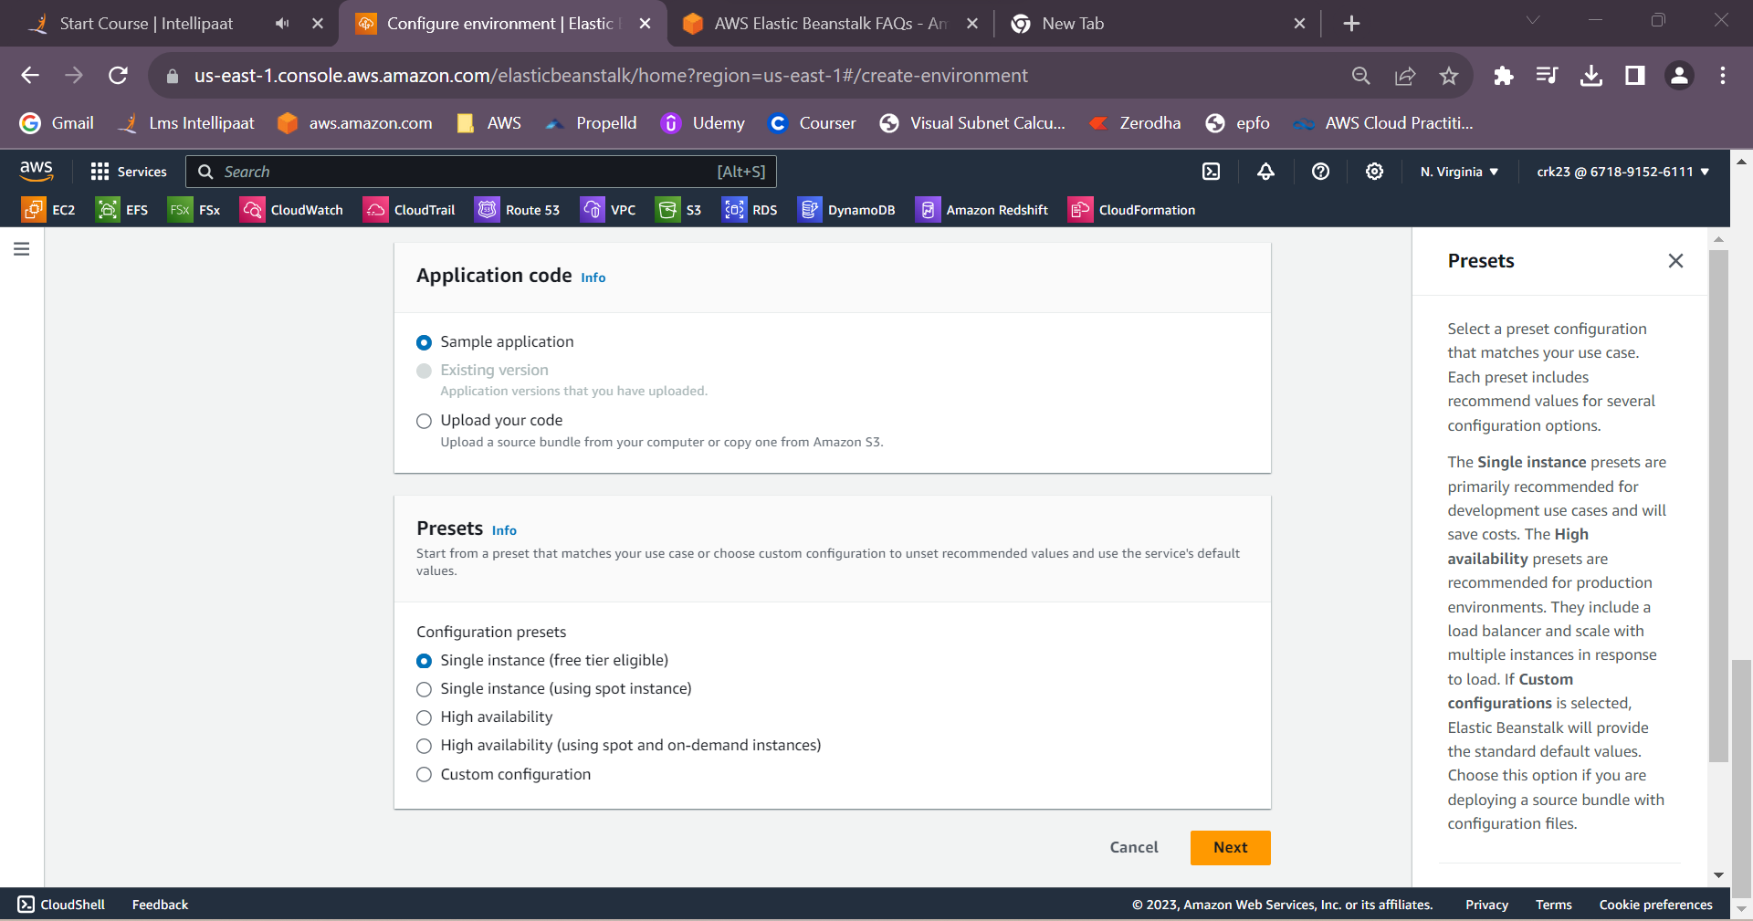

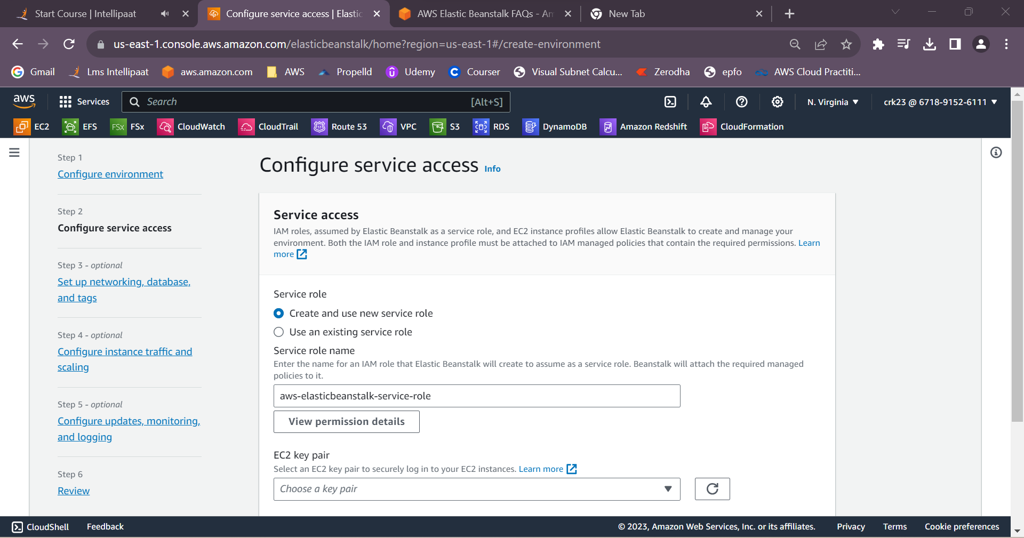

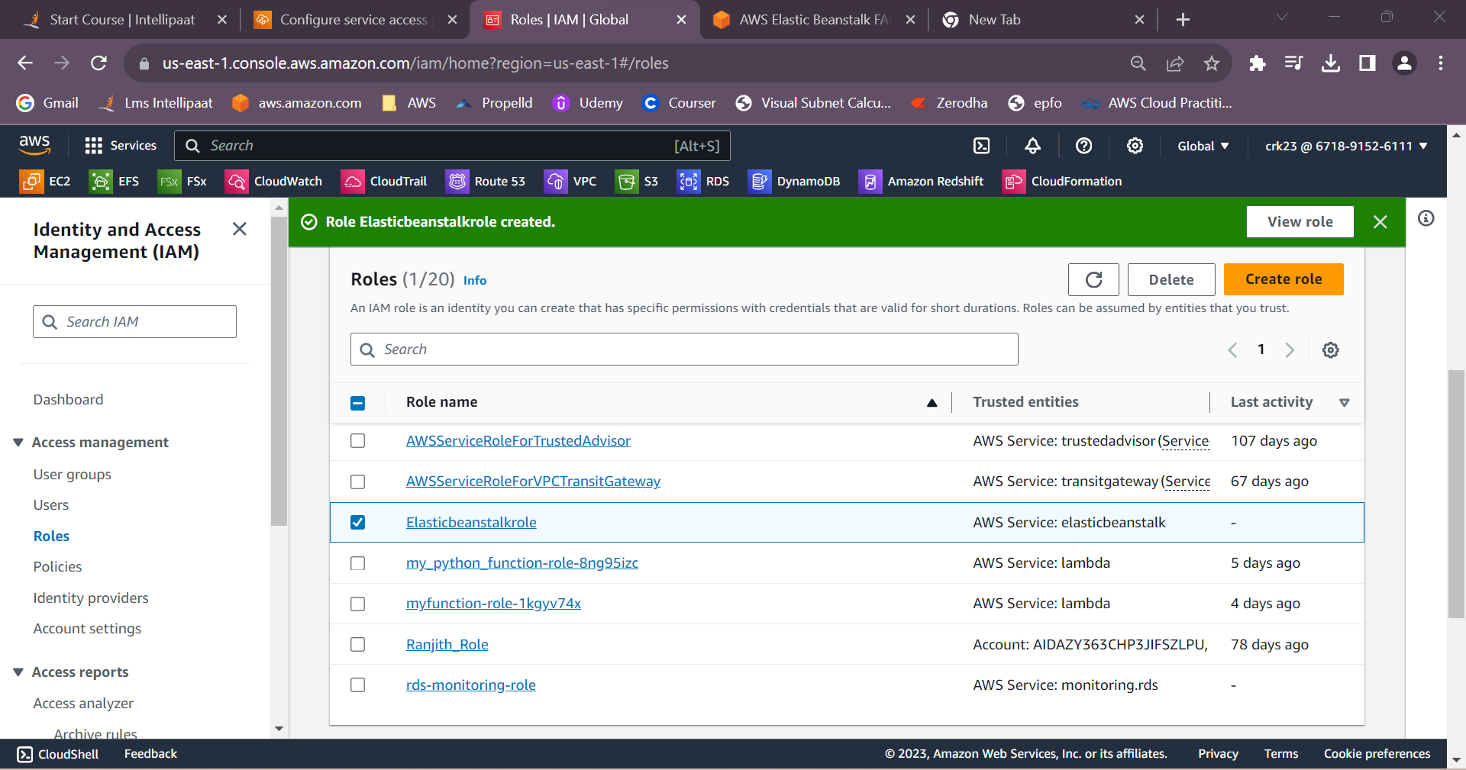

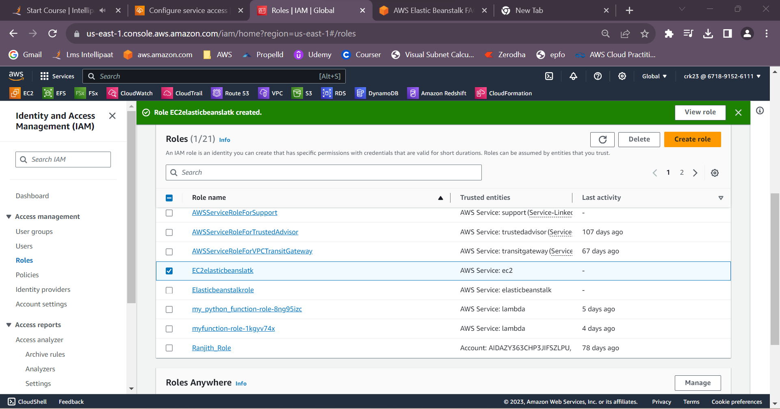

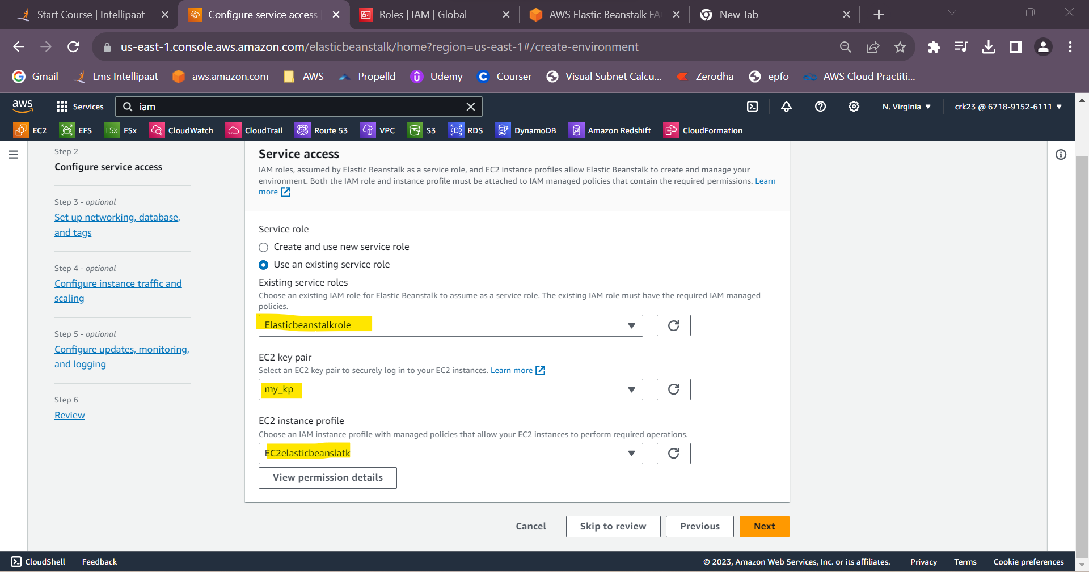

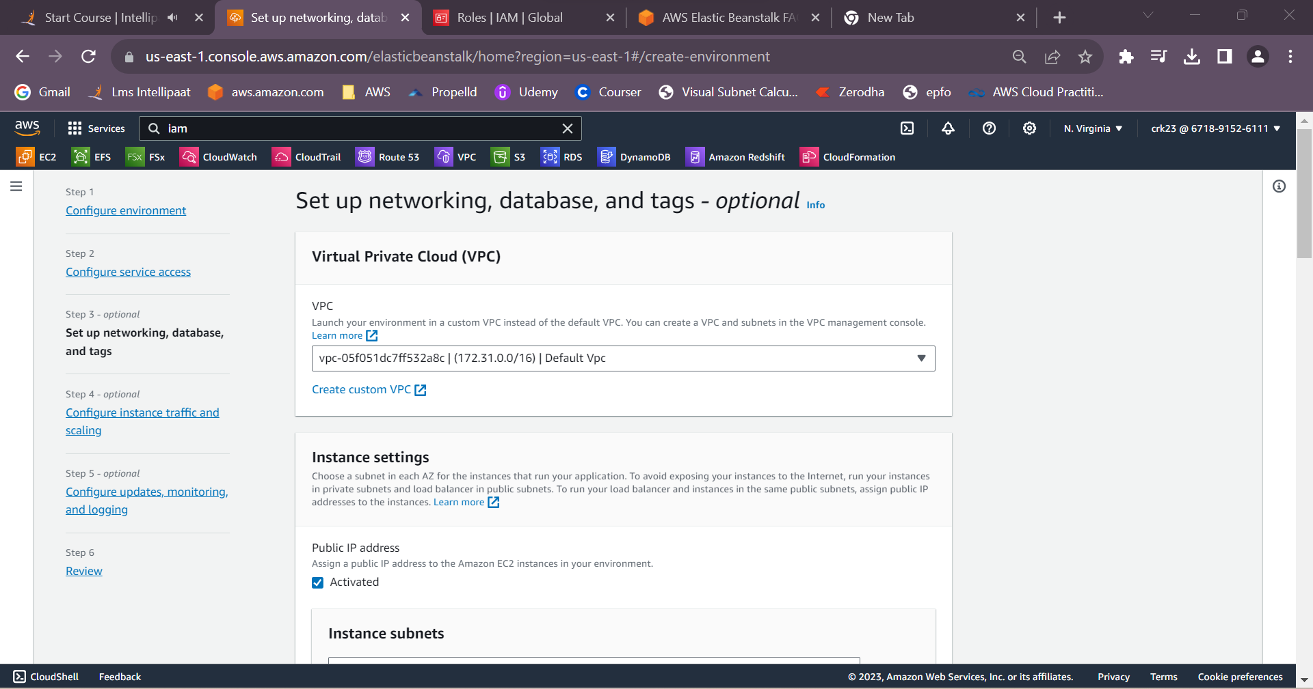

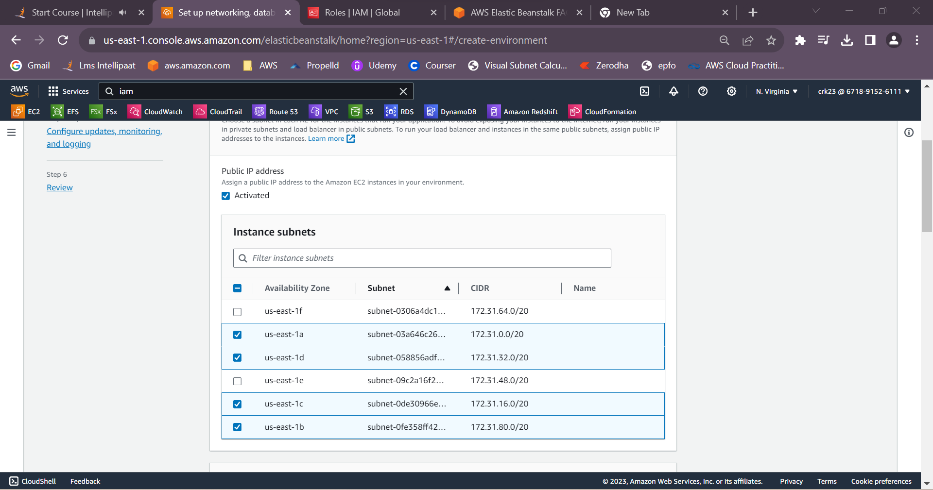

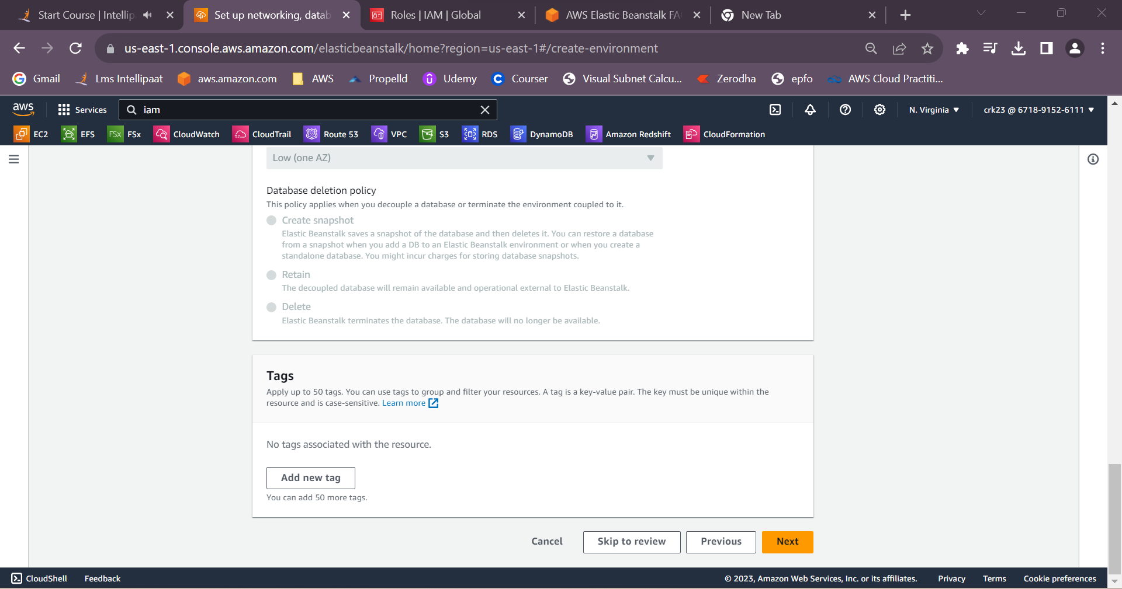

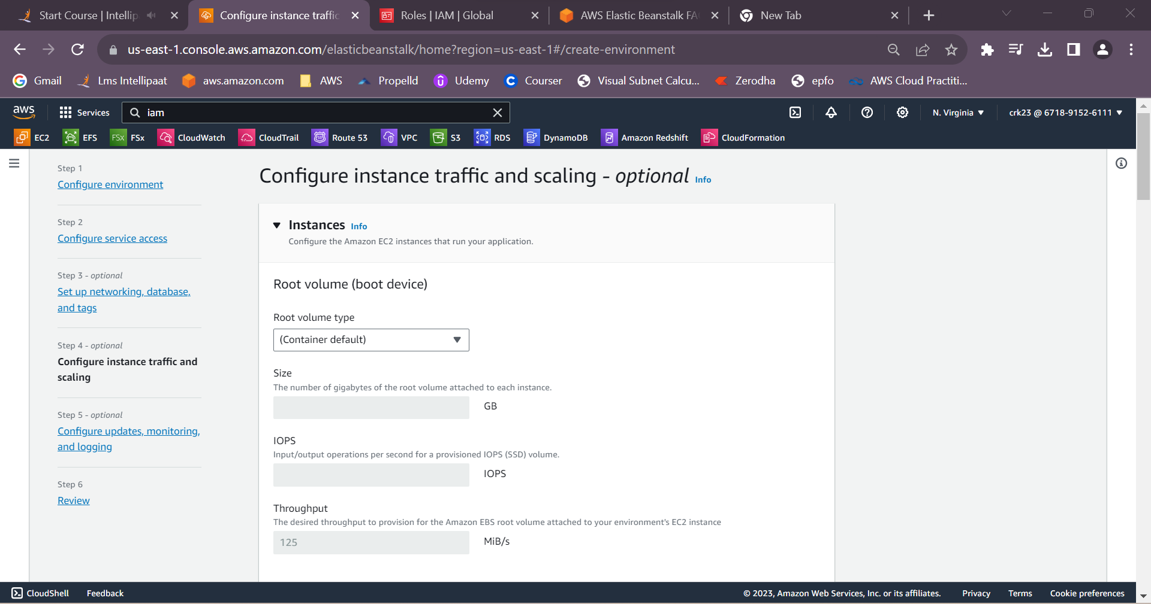

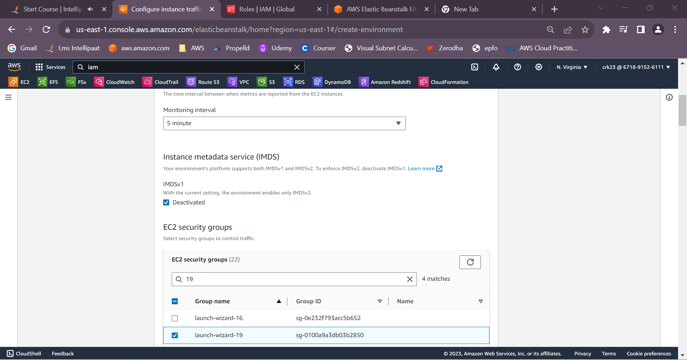

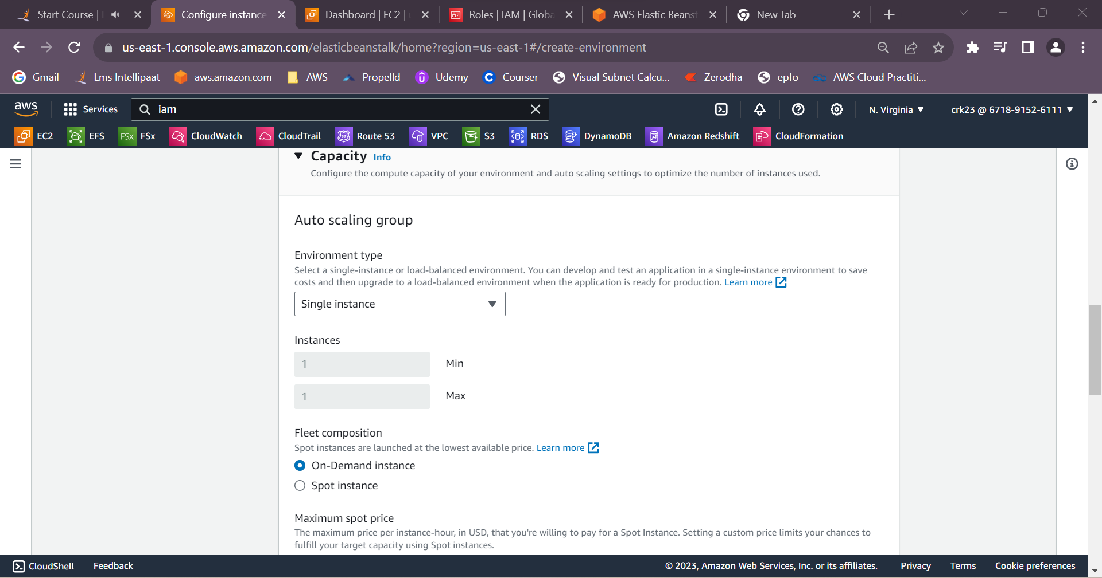

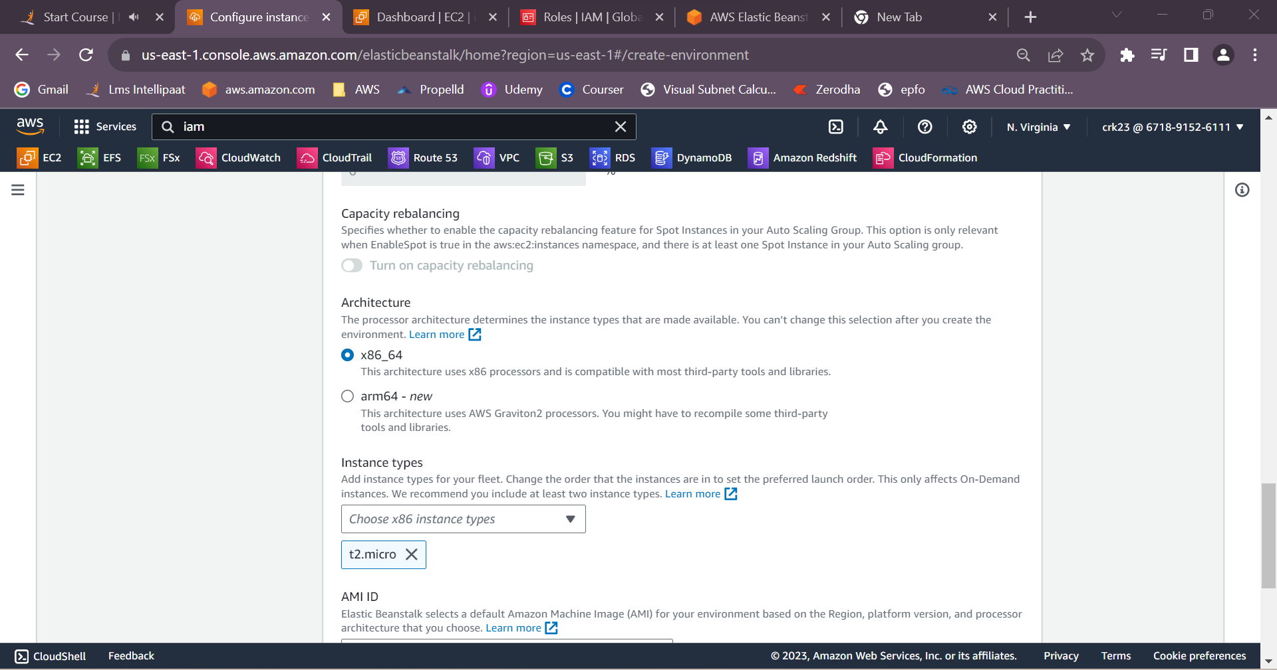

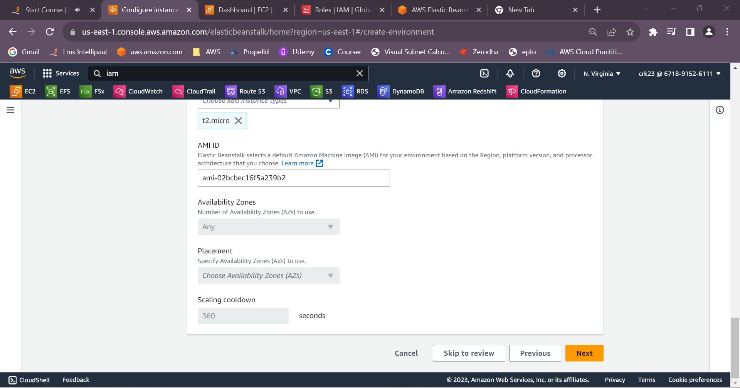

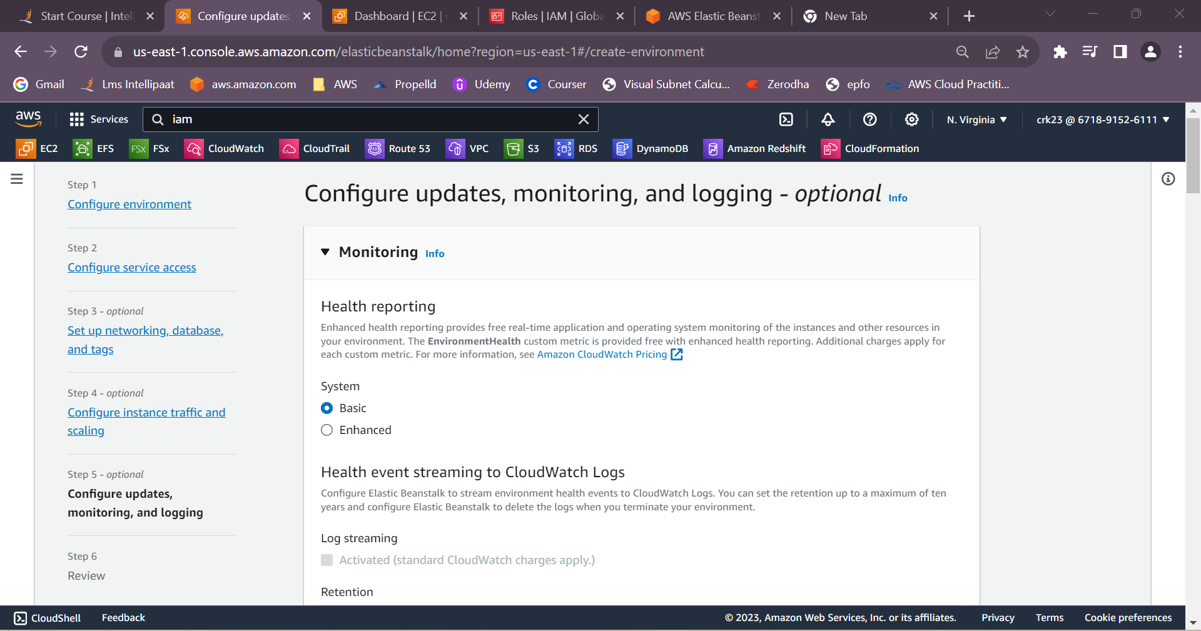

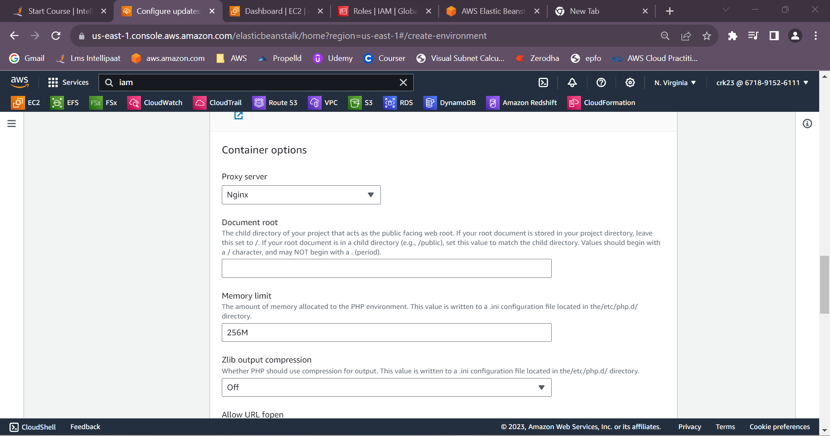

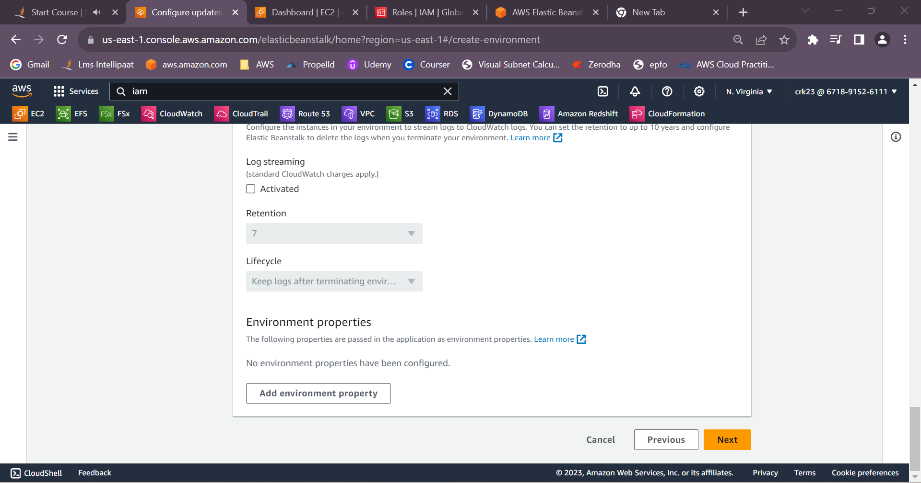

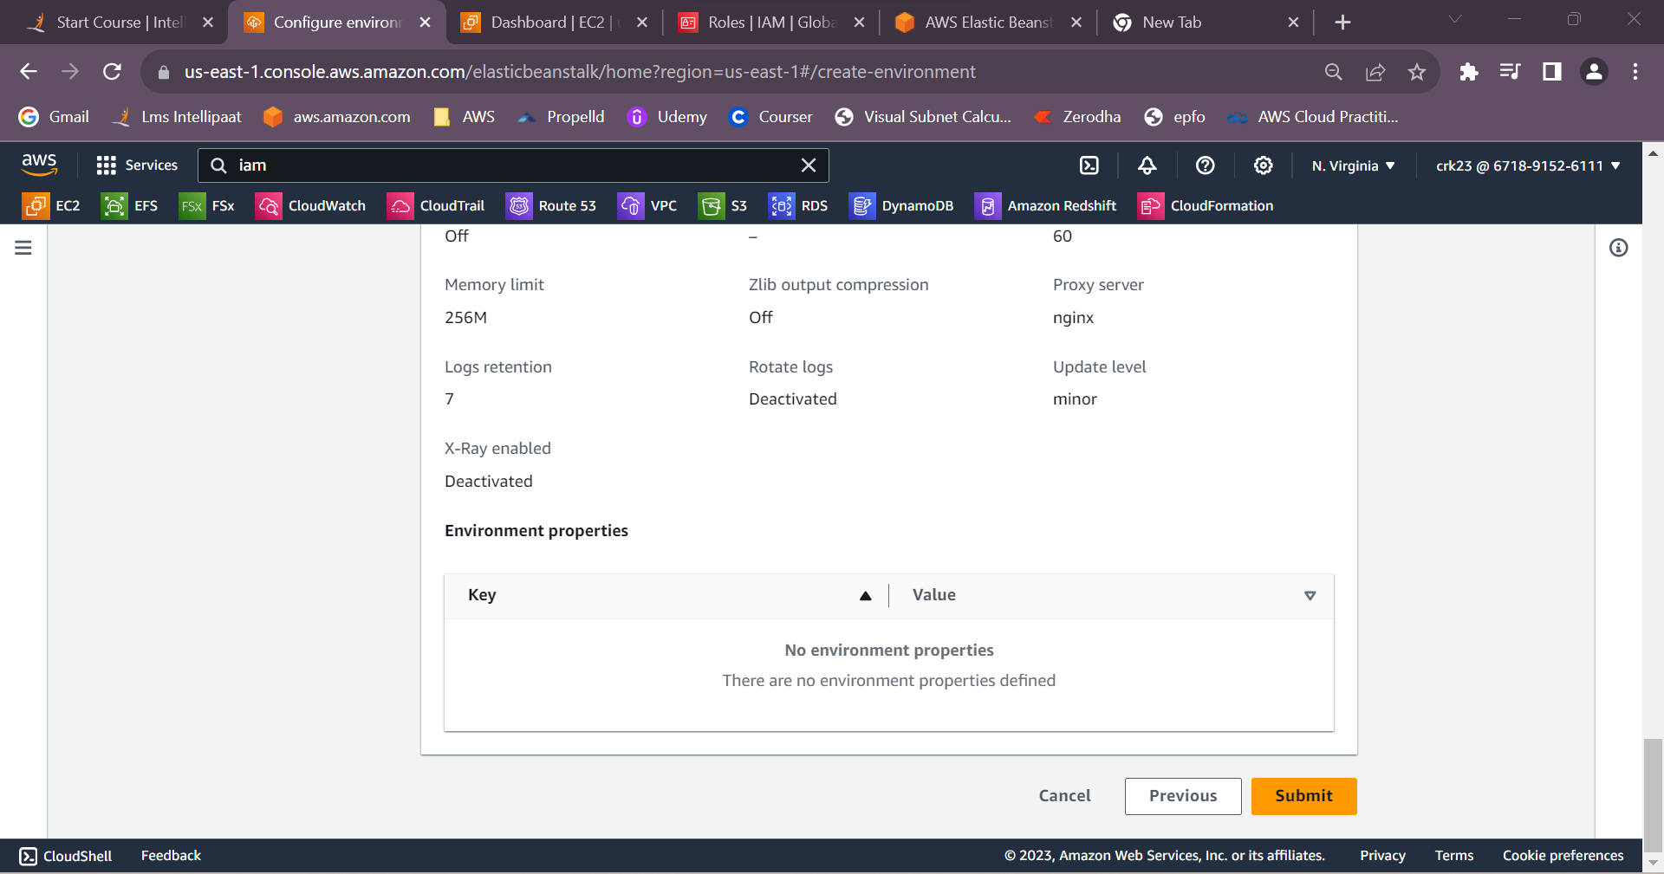

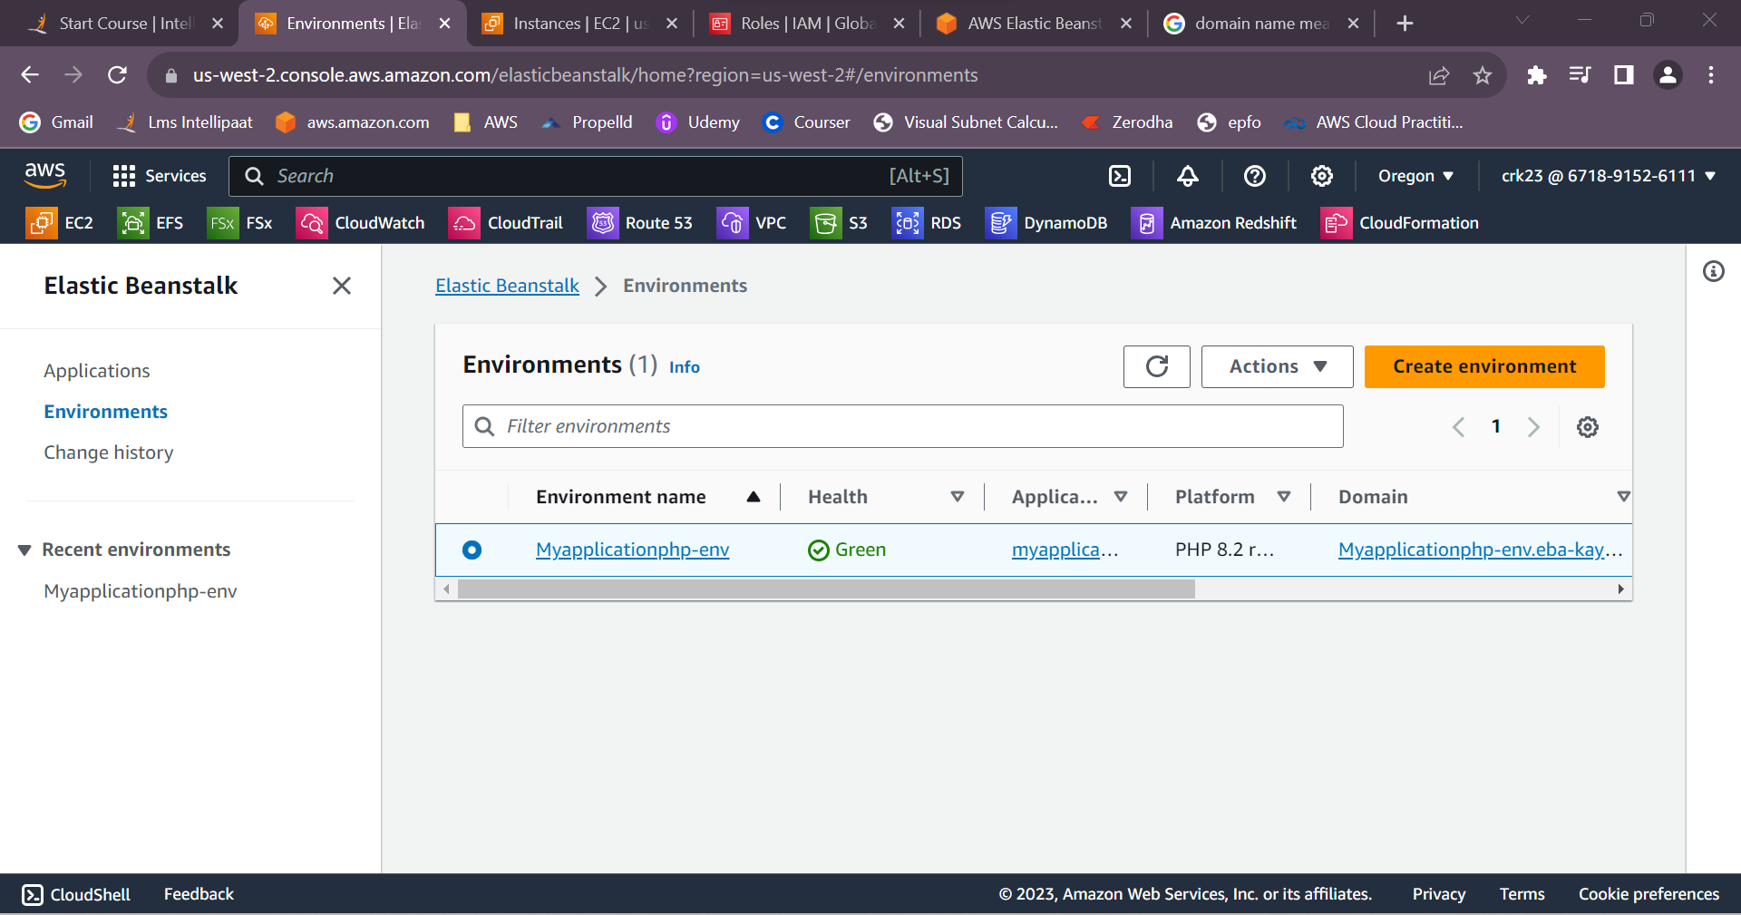

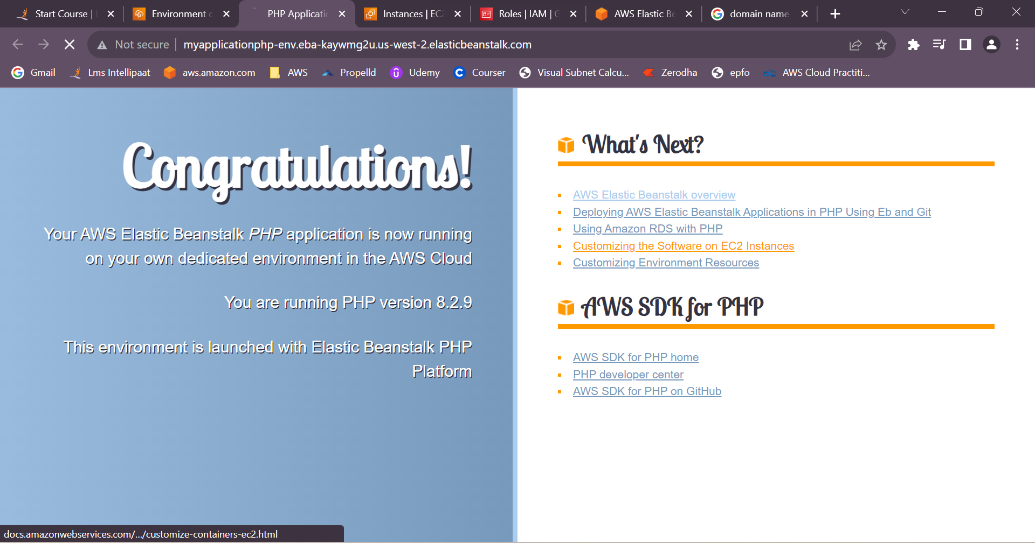

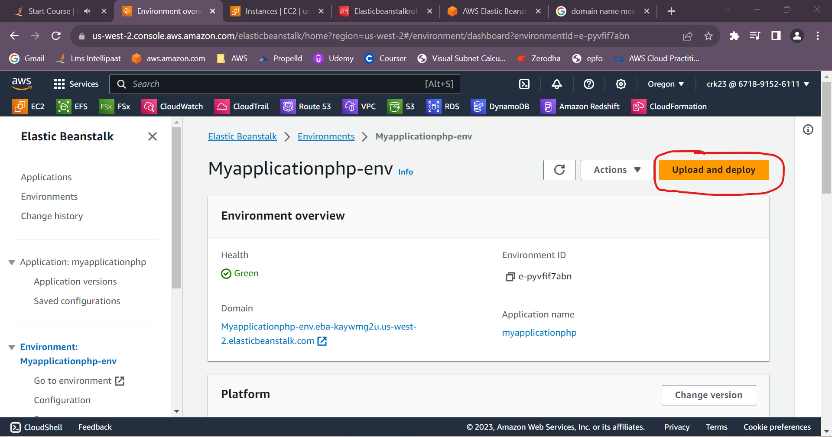

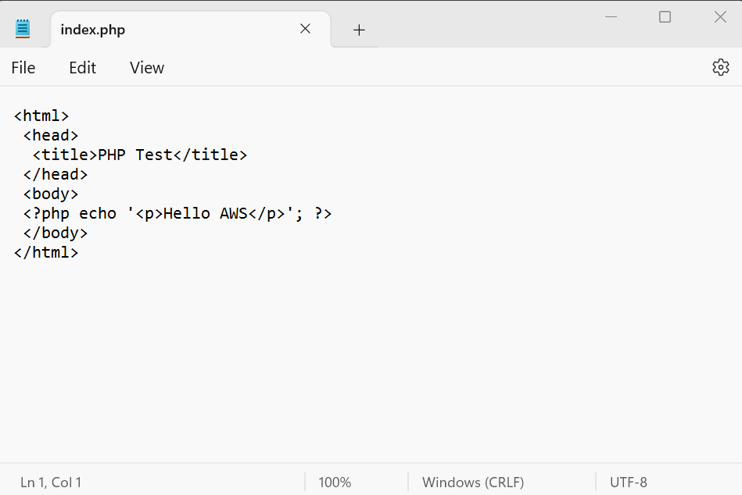

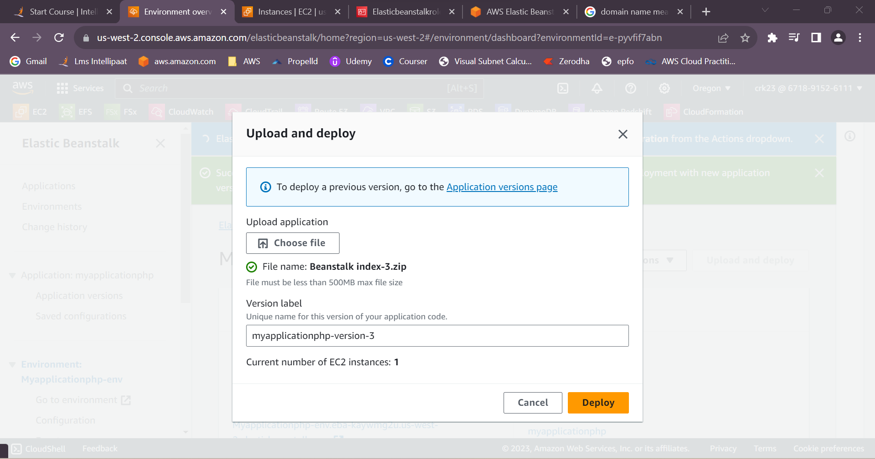

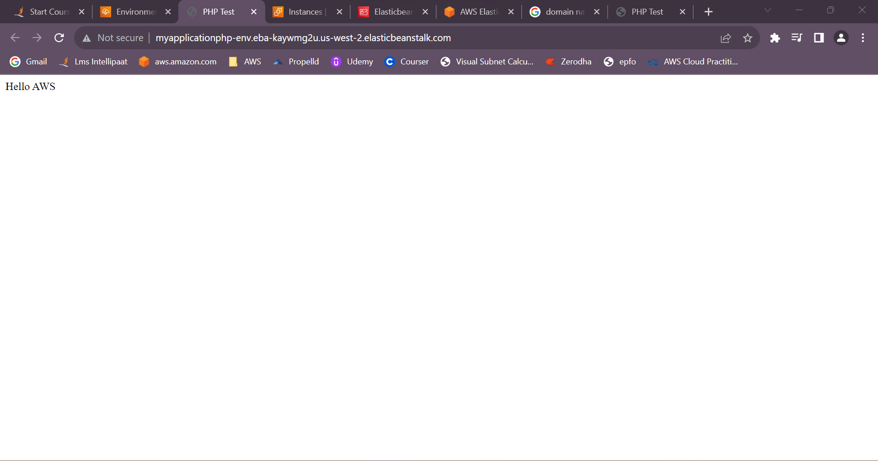

**OUTPUT:**

Created an Elastic Beanstalk environment with the runtime as PHP and upload a simple PHP file.